Landform boundary effects on Holocene forager landscape use in arid South Australia

Ben Marwick (corresponding author)

Peter Hiscock

Marjorie Sullivan

Philip Hughes

06 June, 2017

Landscapes throughout any region vary in the resources they contain. We investigate how Holocene forager populations adapted to this variation in the linear sand dune desert of arid South Australia. We use data from surface scatters of stone artefacts collected during pedestrian survey to compare behaviours at landform boundaries to behaviours at the centers of landforms. We propose a model of human use of the landscape that predicts the prehistoric occupants of the study were sensitive to the different economic potential of subtly dissimilar landscapes. In evaluating the model we find that there are different densities of archaeological sites in each landscape type. We also find indications of a boundary effect resulting from people having used marginal areas of each landscape type in response to the resource characteristics of adjoining landforms. In addition, we make some observations on our field data collection methods, identifying the general conditions where mobile GIS may be optimally efficient for archaeological survey

Affiliations:

Ben Marwick (corresponding author) University of Washington Denny Hall 117, Box 353100 Seattle, WA 98195-3100 USA

1. (+1) 206.552.9450
2. (+1) 206.543.3285  
   [bmarwick@uw.edu](mailto:bmarwick@uw.edu)

Peter Hiscock  
The University of Sydney, Sydney NSW, Australia

Marjorie Sullivan  
The University of Sydney, Sydney NSW, Australia  
Huonbrook and Environment and Heritage P/L, PO Box 97 Moruya NSW 2537, Australia

Philip Hughes  
Flinders University, Adelaide, South Australia, Australia  
Huonbrook and Environment and Heritage P/L, PO Box 97 Moruya NSW 2537, Australia

##### .

## Introduction

A key step in understanding past human use of landscapes is investigating how people adapted their behaviours to the environmental variations they encountered. When analysing the residues of these behaviours, archaeologists often depend on comparing modal attributes of archaeological sites between discrete patches of landscapes (e.g. Barton 2003). Variations in human behaviour at landscape boundaries are more challenging to investigate, despite their importance in understanding sensitivity to landscape differences. Previous work on past human behaviours at ecological interfaces has focused on regions of highly contrasting biomes. For example, Epp (1985) found that archaeological sites were more concentrated in an ecotone (i.e. ecological transition area) where plains grasslands meet the boreal forest in Saskatchewan, compared to within those biomes. Epp’s work is typical of much early archaeological work on ecotones, with claims that ecotonal areas contain higher populations and diversities of flora and fauna (Struever 1968; Glassow and Leone 1972). This increased variety and density of plants and animals, often described as an ‘edge effect’, has been a focus of archaeological research. For example, it was claimed by Harris et al. (1969) to be a causal factor in the emergence of agriculture. This edge effect was also extended to human culture, with Gummerman and Johnson (1971) arguing for increased human cultural diversity in ecotonal zones of central Arizona. In Australia edge effects in landscape resources and their exploitation have also been discussed. For instance, Hughes and Hiscock (1982) noted apparent edge effects in the concentration of stone artefact scatters along landscape boundaries in arid northern South Australia.

These uses of the ecotone and edge effect concepts declined in the archaeological literature after several critiques pointed out that archaeologists had been overly simplistic in their use of many ecological concepts (Rhoades 1978; Hardesty 1980; King and Graham 1981). Problems with these previous approaches include ignoring controversies among biologists about the definition of ecotones, unjustified assumptions about the uniformity of all ecotones, and unverified assumptions about edge effects always increasing the amount of food species available to humans. Alternative approaches to investigating landform boundary effects can be found in the work of Kimes et al. (1982), who used distribution of artefacts to see how culture group areas related to landform boundaries. However, much recent work on archaeological settlement patterns of hunter-gatherers has eschewed boundaries in favour of analysing straight line distances from key resources such as raw materials for stone artefacts, as these can be easier to measure and interpret than landscape boundaries (Daniel 2001; Jones et al. 2003). Here we pursue a new approach to understanding boundaries by focusing on subtle variations in landscape characteristics within a biome, rather than between them. By focusing on continuous variation, rather than step-wise shifts in the archaeological record across ecological interfaces, we introduce a new approach to studying behaviours of prehistoric forager groups at interface zones.

In this study we use the results from a sample of hand-held GIS-enabled archaeological site recordings to ask if it is possible to observe gradients of change in archaeological materials over distance to understand forager choices of the optimum locations for their activities in respect to environmental boundaries. We predict that prehistoric foragers were sensitive to subtle differences in resource structure as gradients across the landscape. This approach may be contrasted with concepts of linear boundaries with step-wise shifts in habitability. The step-wise approaches are useful because they make comparative landscape analysis more tractable in many contexts and at different scales. For example, the spatial scales of much previous work on prehistoric arid zone foragers has ranged from continental (Williams et al. 2013; Bird et al 2016) to ecological regions (Holdaway et al. 2013). In this paper, we introduce a novel focus on human behaviour in the arid zone: the interface between two types of subtly different landscapes. We show that prehistoric forager groups' decisions about how they occupied the study area were sensitive to subtle differences in local landscape characteristics.

Our work is motivated by previous archaeological work on cultural landscapes of foragers in Australian arid and semi-arid zones that emphasizes the relationship between settlement organization and both exploitable resources and prominent landscape features such as dunes, occurrences of flakeable rocks, pans, springs and salt lakes (Hughes and Hiscock 1982; Veth 1993; Napton and Greathouse 1996; Holdaway 1998; Barton 2003; Smith 2006; Fanning et al. 2008; Smith et al. 2008; Veth et al. 2008; Williams et al. 2013; Davies et al. 2015; Gould and Saggers 1985). The archaeological signature of landuse on these landscapes has typically been the distribution and composition of surface stone artefact scatters, which are by far the most abundant type of site. Sites in these landscapes are typically small, dense and discrete concentrations of stone artefacts that represent temporary, short-term activity areas.

##### .

Our study area in the Roxby dunefield in northern South Australia (Figure 1), offers a unique opportunity to study landscape interfaces for two key reasons. First, in our study area these interfaces are relatively well-defined by landform attributes, such as the surface geology (Table 1) and physical features such as the spacing between sand dune ridges or the presence of water bodies (Table 2). The interfaces in our study area can be recognized as linear boundaries, often following the ridges or swales of the sand dunes and bounaries other physical features, making them convenient for spatial analysis of archaeological features (Figure 2). With clear landscape unit boundaries, our study area is well-placed to explore relationships between archaeological attributes and distances from these boundaries.

The second reason why our data are uniquely suited to investigating landscape boundary effects is that we have a large number of sites spread across several landscape types. The relatively high density of sites provides an opportunity to investigate fine-grained gradients of archaeological change over multiple landscapes and their interfaces. More specifically, we can test whether a boundary effect exists at the edge of landscape units by examining how the size and density of surface clusters of stone artefacts changes with their distance from the boundaries.

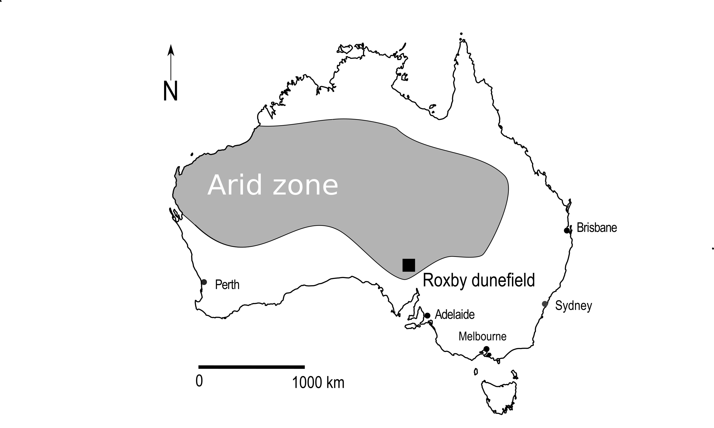

Figure 1 Map of region including the study area

##### .

Table 1 Geological regimes in the study area and predicted archaeological importance. Adapted from Hughes et al. (2011).

|  |  |  |  |
| --- | --- | --- | --- |
| Geological regime | Period | Description | Materials for artefact manufacture |
| Q | Quaternary | Aeolian sand dunefields and clay pans | No materials exposed |
| Czs | Cainozoic (Tertiary) | Silicified sandy beach ridges of an ancient lake to the west | Main source of silcrete |
| K | Cretaceous | Deeply weathered kaolinitic siltstones, shales and sandstones (Bulldog Shale). Extensive deposits of ice-rafted pebbles, cobbles, boulders, predominantly quartzite | Main source of quartzite. Some ice-rafted chert and quartz. Some silcrete from silicified weathered sediments |
| A | Cambrian | Andamooka Limestone | Main source of chert |
| P | Precambrian | Simmens Member of the Arcoona Quartzite | Flaggy quartzite less suitable for flaking but source for grinding stones and hearthstones |

##### .

Table 2 Landform types and predicted archaeological signature. Adapted from Hughes et al. (2011), Kinhill-Stearns Roger (1982), Hughes and Sullivan (1984), and Sullivan et al. (2014a).

|  |  |
| --- | --- |
| Landform type | Archaeological prediction |
| 1 and 2. Flat to gently undulating dissected tableland/plateau surfaces with occasional low hills | Sites occur infrequently and then are mainly quarries and knapping floors where locally available materials have been exploited. Quarries commonly very large (>1,000m2) with high density artefact clusters (1-10/m2). Where isolated dunes occur they generally contain rich, diverse artefact clusters |
| 3. Broad drainage depressions surrounding large claypans | Sites occur infrequently, mainly on sand dunes around the margins of large moisture-holding depressions. Sites very large with very high artefact densities (>10/m2). High diversity of stone materials and implement types. These characteristics indicate the drainage depressions and associated dunes were focal points for occupation and a range of domestic activities. |
| 4. Plateau surfaces with widely spaced east-west trending sand dunes; numerous large claypans in the swales | Sites are medium to large (10-1,000m2) with medium to high artifact densities (0.1-10/m2) and a range of implement types. Artefacts on a low to medium diversity of stone materials. Most sites are artefact clusters on dunes concentrated around pans. In terrain patterns formed on K, A and P site frequencies low to medium. On Czs, where silcrete crops out most frequently, there are quarries and associated knapping floors and site frequency is very high. Compared with landform types 1, 2 and 3, sites in landform type 4 are more evenly dispersed across the landscape. Artefact clusters occur more frequently, are richer and are more diverse on sand dunes adjacent to pans. Sites in dunes adjacent to quarries (especially silcrete) consist of knapping floors with low diversity of stone material. The richest sites are in dunes adjacent to areas where pans and silcrete quarries occur in close proximity. |
| 5. Plateau surfaces with moderately-spaced dunes covering 30-60% of the landscape. Claypans are smaller and less common than in widely spaced dunes. | The nature and distribution of sites follow the same pattern as that for landform type 4 but sites occur less frequently and are less rich. This reflects the less common occurrence of pans and outcrops of raw material, due to the increased cover of sand. |
| 6. Plateau surfaces with closely-spaced dunes covering at least 80 % of the landscape. Claypans are uncommon. | Sites occur very infrequently because of the almost continuous cover of sand, the absence of surface water and stone sources, and the practical difficulty in traversing these landscapes. |

##### .

Figure 2 Aerial photograph showing a sample of landscape types and their boundaries in the study area.

Figure 2 Aerial photograph showing a sample of landscape types and their boundaries in the study area.

##### .

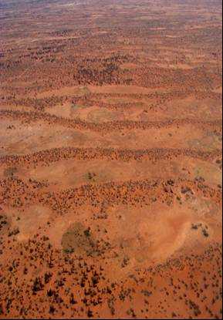

Figure 3 Aerial photograph showing Terrain Pattern Q4 in the foreground, consisting of widely spaced sand dunes with only poorly developed pans and no rock outcrop in the swales. The more closely spaced dunes in the background are in Terrain Pattern Q5

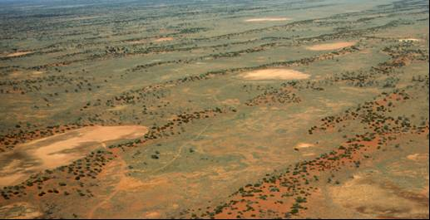

Figure 4 Aerial photograph showing Terrain Pattern Qs4, consisting of widely spaced dunes with well-developed pans and patchy areas of bare rocky ground exposed in the swales. The exposed rock is predominantly silcrete.

##### .

## The Roxby dunefield and investigation of its archaeology

The Roxby dunefield is in the driest part of the Australian arid zone (Figure 1). Archaeological material is found across the broader region and partly reflects the long period of human occupation, the wide range of locally available resources and the extremely low rates of sediment movement that might otherwise obscure surface artefacts. Optically stimulated luminescence (OSL) dating of sediments underling buried artefacts in several sites demonstrate episodic human use of the area from the late Pleistocene deglacial period (from around 19 ka, Hughes et al. 2014b; Sullivan et al. 2012; Sullivan et al. 2014b). No organic materials have been found at any of the open sites or in the excavated deposits. Distinctive implement forms such as backed artefacts, unifacial points and tula adzes at many sites in the study area indicate a mid to late Holocene age for the main period of land use and for most of the surface artefact clusters recorded during the survey (Hughes and Hiscock 2005). A study of 78 OSL ages from geological contexts in the study area has shown that the mid to late Holocene period was a time of broad-scale dune stability (Hughes et al. 2014b). This means that site preservation and visibility is not strongly controlled by dune movement during that period. In 2013 we returned to sites that had been recorded 25 years earlier and found them to be in the same state as originally recorded, indicating that site visibility has changed little over 25 years.

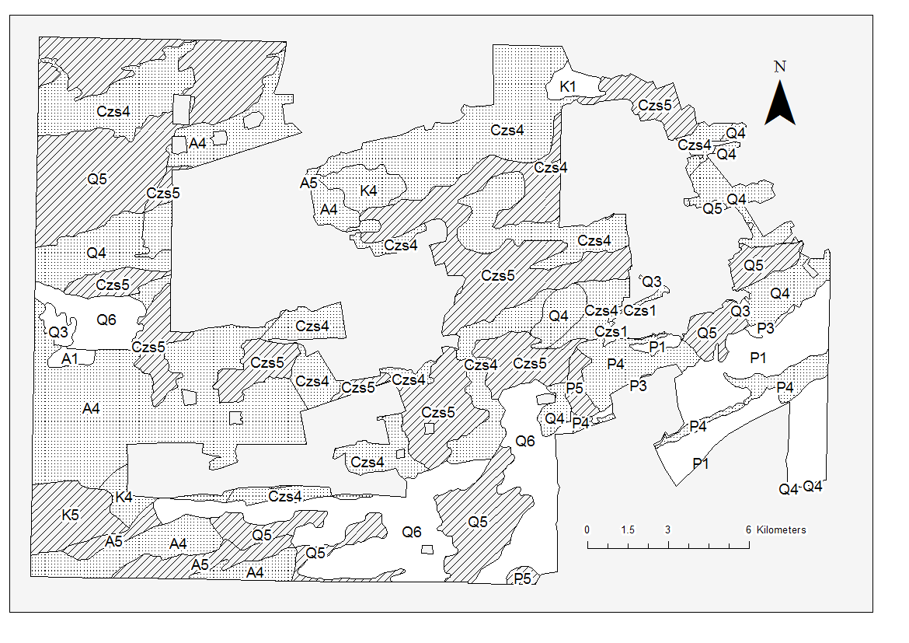

Figure 5 Map of our study area within the Roxby dunefield, showing landforms and terrain patterns. Each polygon is labelled with 1-3 letters that denote the surface geological regime (see Table 1 for more details), and a number that denotes the landform type (see Table 2 for more details).

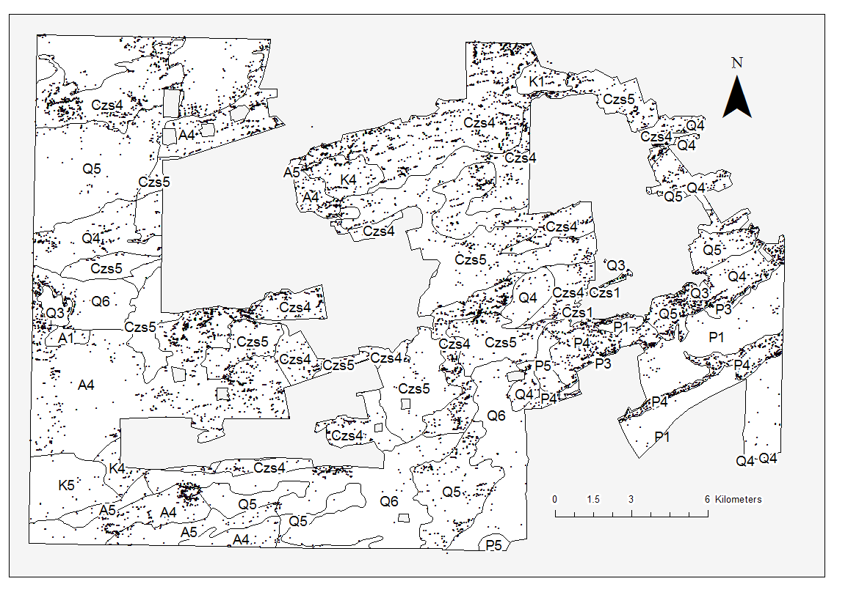

Figure 6 Map of study area showing the distribution of archaeological sites sampled for this study

The Roxby dunefield has been the target of mineral exploration and mining since the 1980s. The extensive records of archaeological sites near the Olympic Dam mine site in the dunefield have been created during research-orientated consultancy work related to this exploration and mining activity. In 1980 Hughes, Hiscock and colleagues commenced a range of archaeological investigations for the then-proposed mining project. They used terrain patterns based on combining categories of different landforms and surface geology (Figure 5) to develop an environmentally-based model to predict the nature and distribution of archaeological sites (Hughes and Hiscock 1982). The landscape consists of ancient stony plateau (or tableland) surfaces partly overlain by fields of longitudinal east-west dunes. Many of the interdune corridors (or swales) and extensive flat to gently sloping plateau surfaces without dunes are covered by a lag of gravels and cobbles referred to as gibber. Water sources include ephemeral small lakes, claypans and canegrass-vegetated swamps which are subject to high evaporation rates, with no free water available for most of the year. In this region vegetation patterns were also determined by the presence or absence of sand, gibber surfaces and water bodies (Badman 1999). This means that there are long-term relationships between the landscape units employed in the analysis of Hughes and Hiscock (1982), and plant and animal resources exploited by forager communities in the past.

##### .

Hughes and Hiscock’s archaeological model has been described in detail in previous publications (Hughes et al. 2011; Hughes and Hiscock 1982). In brief, the model details how the location and character of archaeological sites are influenced by proximity to fresh water, sand on which to camp, and locally available raw materials for flaking stone artefacts. The model results in a series of predictions about the archaeological record expected for each of six landform types (Table 2) and five geological regimes (Table 1). These predictions specify the frequency of sites and the density and diversity of artefacts which were produced for each major landscape unit.

These descriptions were initially tested in the 1980s and 1990s by archaeological surveys of the mining area and infrastructure corridors. The predictive model was based on records from an initial 133 sites and by 2007 additional testing and surveys of water and power supply corridors had resulted in a database totaling 820 archaeological sites (Hiscock and Hughes 1983; Hiscock 1989). In 2007 a proposed expansion of the existing mine triggered the need for an intensive archaeological survey of an additional area of 515 km2 surrounding the existing mine, to be completed by the end of 2009. The data collected during that survey is the basis for this study (Figure 6).

## Methods and Materials

Between 2007 and 2009 teams of archaeologists and trainees from local Aboriginal groups walking across the entire area recorded more than 17,000 archaeological sites (Sullivan et al. 2014a). In this study we draw on a sample of 10,615 sites from a 353 km2 area within the Roxby dunefield (Figure 6). The sites consist of stone artefact clusters (85.3%), artefact clusters with knapping floors (7.6%), knapping floors (4.8%) and quarries (0.7%) (Hughes et al. 2011). Extended descriptions of site definitions and survey methods have previously been presented in Hughes et al. (2011) and Sullivan et al. (2014a).

To collect field data, we used a mobile geographic information system (GIS) on handheld computers to record background environmental, cadastral, and archaeological information. Our equipment was similar to what is commonly used during field survey (McPherron and Dibble 2003; Bevan and Conolly 2004; Tripcevich 2004a; 2004b; Given and Hyla 2006; Wagtendonk and De Jeu 2007; de la Vega and Agulla 2010; Tripcevich and Wernke 2010; Fei 2011; Scianna and Villa 2011, Traviglia 2011, Fee et al. 2013; Newhard et al. 2013; Cascalheira et al. 2014; Banning and Hitchings 2015). Our mobile GIS configuration files, recording forms, and scripts are archived online at <http://doi.org/10.5281/zenodo.11833>. A detailed description of our specific hardware, software, and justifications for our choices is presented in our SOM.

### Investigating boundary effects

We investigated behaviours at landform boundaries by analyzing the contrast between archaeological sites close to the boundary of a landform and the archaeology deeper within the landform. Our test of boundary effects focused on the archaeological evidence from resource-rich landform types/terrain patterns, such as Czs4, bordered by landscapes with lower resource levels, such as landform types 5 or 6. Because Czs4 and Czs5 dominate the 353 km2 sample area and contain the majority of sites, the analyses focused on comparing these two terrain patterns.

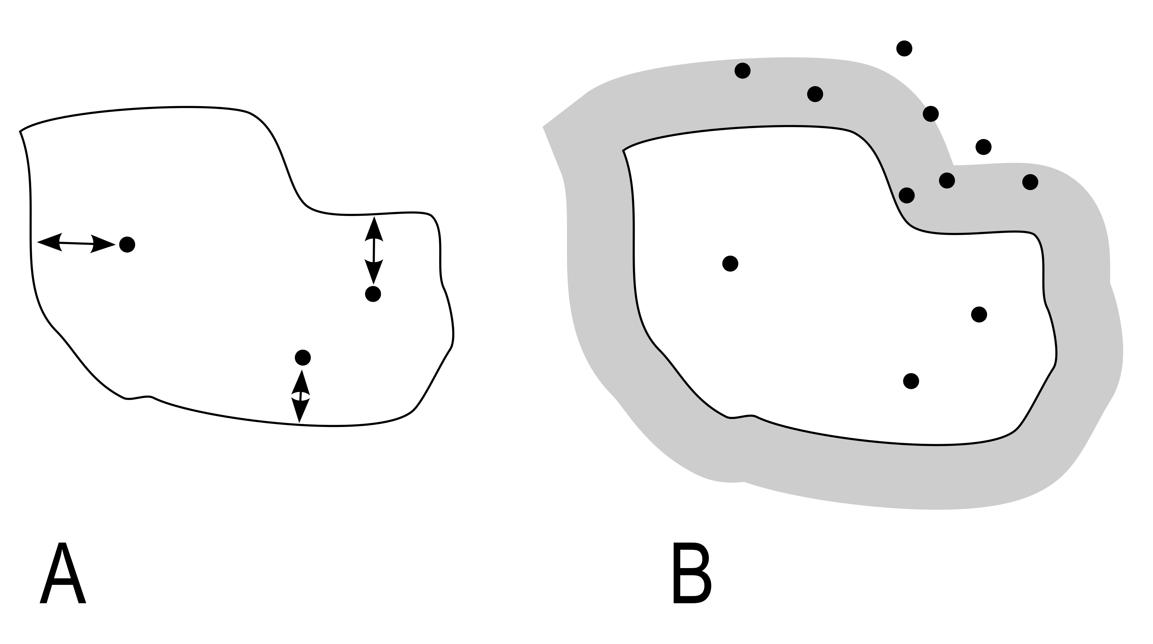

Figure 7 Schematic of two approaches used to investigate boundary effects in the Roxby duenfields, South Australia. A: the straight-line distances from sites to the boundaries of the terrain patterns that they are contained in was measured. B: the number of sites per square kilometer was measured in a series of buffer areas, an example of a buffer area is indicated here by a grey region at the exterior of the terrain pattern area.

We used two approaches (Figure 7) to investigate the presence and character of boundary effects in the Roxby dunefield – a landscape consisting predominantly of longitudinal sand dunes and stony desert (gibber plains). In the first approach, we determined the straight-line distance from every site to the nearest boundary of the terrain pattern in which it was contained. By comparing the distributions of these distances and using statistical tests we can see if there are diffrences in the patterns of site proximity to landform boundaries. These data will allow us to test the prediction that sites tend to be closer to the edge of some landforms than other landforms.

In the second approach, we measured the density of sites per square kilometer at 100 m intervals, or buffer zones, inwards from the boundary of the terrain patterns Csz4 and Csz5, as the best represented terrain patterns. These data were used to test the prediction that site densities tends to be higher towards the center of Csz4, as a resource-rich landform, compared to Csz5, as a resource-poor landform. We created interior buffer polygons at 0-100 m, 101-200 m and 201-300 m from the boundary of the terrain patterns and the number of sites per square kilometer in each buffer was measured. The density of sites in each buffer zone was then divided by the average density for the entire terrain pattern to standardize the density value for the terrain pattern. Z-scores were calculated to put the differences in site density on a comparable scale between the two terrain patterns. Z-scores are a transformation of the data that show how many standard deviations the site density in each buffer polygon varies from the mean density (z = 0) of all the buffers in each terrain pattern. This second approach provided a way to minimize the effect of differences in the sizes of landscape units being compared. It does this by limiting analysis to an area 300 m from the boundary of the terrain pattern, thereby excluding sites in the middle of very large area terrain patterns.

### Reproducibility and open source materials

To enable re-use of our materials and improve reproducibility and transparency according to the principles outlined in Marwick (2016), we include the entire R code used for all the analysis and visualizations contained in this paper in our SOM at <http://dx.doi.org/10.17605/OSF.IO/RMKGE>. Also in this version-controlled compendium are additional regression diagnostics. To respect the wishes of our stakeholders and protect the site locations from potential damage we have not made our data openly available. In our SOM our code is released under the MIT license, and our figures as CC-BY, to enable maximum re-use (for more details, see Marwick 2016).

## Results

### Efficiency of a mobile GIS compared to paper systems for field survey

Our survey activity in the Roxby dunefield region over multiple decades has provided us with an opportunity to collect longitudinal data on site recording methods. Here we briefly explore the question of whether our mobile GIS enabled faster site recording compared to when we used a paper-pen-GPS method (these methods are described in more detail in our SOM). Table 3 shows a summary of the productivity of archaeological survey before and after we implemented our mobile GIS. Although there are many possible metrics of productivity, one that was especially relevant for our project was the number of sites recorded per person per day. This metric is useful because it is easy to measure without burdening field workers with additional data-logging tasks. However, we need to take into account possible confounding factors, such as travel time to the day’s survey area, the size and density of the sites in the day’s survey area, skill and efficiency of the individual archaeologist and the sampling strategy.

Table 3 Summary of archaeological survey productivity in the Roxby dunefield. The data for sites recorded per person per day for before 2007 come from a survey undertaken in 1982 by Philip Hughes and Peter Hiscock that recorded 176 sites in 50 person days.

|  |  |  |  |  |
| --- | --- | --- | --- | --- |
|  | pre-2007 | 2007 | 2008 | 2009 |
| Area surveyed (km2) | 35.0 | 95.0 | 275.0 | 145.0 |
| Rate of survey (km2/person/day) | 0.0 | 0.3 | 0.3 | 0.3 |
| Total no person-days | 0.0 | 317.0 | 917.0 | 483.0 |
| Approximate number of sites recorded | 665.0 | 3900.0 | 6600.0 | 5500.0 |
| No sites recorded/person/day | 3.5 | 12.3 | 7.2 | 11.3 |
| Frequency of occurrence of sites/km2 | 19.0 | 41.0 | 24.0 | 38.0 |

Our pre-2007 data were collected by more experienced archaeologists than the 2007-2009 data, using a recording form with less variables than our mobile GIS recording forms, and the pre-2007 survey areas were all closer to the camp, with less travel time compared to the 2007-2009 data. Further, the average site size for the pre-2007 data is less than the 2007-2009 data. These conditions should favor a higher rate of recording for the 2007-2009 data. Table 3 shows that prior to adopting the mobile GIS in 2007 we recorded 3.5 sites per person per day. With the mobile GIS our rate increased substantially to an average of 10.3 sites per person per day for 2007-2009.

While this is a substantial difference, not all of this increase in the rate of recording can be attributed to the use of the mobile GIS. This is because the rate of recording is strongly predicted by the density of sites (F(1, 2) = 53.621, R2adj = 0.946, p = 0.018). To isolate the effect of site density on recording rate we computed a linear model for the 2007-2009 data, which resulted in a rate of site recording that can by predicted by 0.043 (0.209) + 0.298(site density) (0.006) + (standard errors in parentheses). This model gave a good fit (R2adj = 0.999, p = 0.013), and was then used to predict the site recording rate using a mobile GIS given the density of 19 sites/km2 observed in the pre-2007 data. The resulting rate is 5.7 sites/person/day, which is what the model predicts if a mobile GIS had been used to record sites in an area with 19 sites/km2. The difference of 2.2 sites/person/day between the actual pre-2007 average rate of 3.5 and the predicted average rate of 5.7 is most likely due to the use of mobile GIS. This represents a 63% increase in the site recording rate, although we caution that this may be an overestimate due to overfitting from the relatively small number of data points in our efficiency analysis.

### Model validation

The data from the Roxby dunefield allow a test of the predictions of the landuse model developed for the region in the early 1980s (Hughes et al. 2011). The first prediction tested here is that there was differential use of terrain pattern areas within dunefields. More specifically, we predicted that areas of widely-spaced longitudinal sand dunes were intensely occupied, compared with areas containing more closely-spaced dunes. This difference is anticipated because of the greater range and density of animal foods, stone for making artefacts, and water sources in places where dunes are more widely separated.

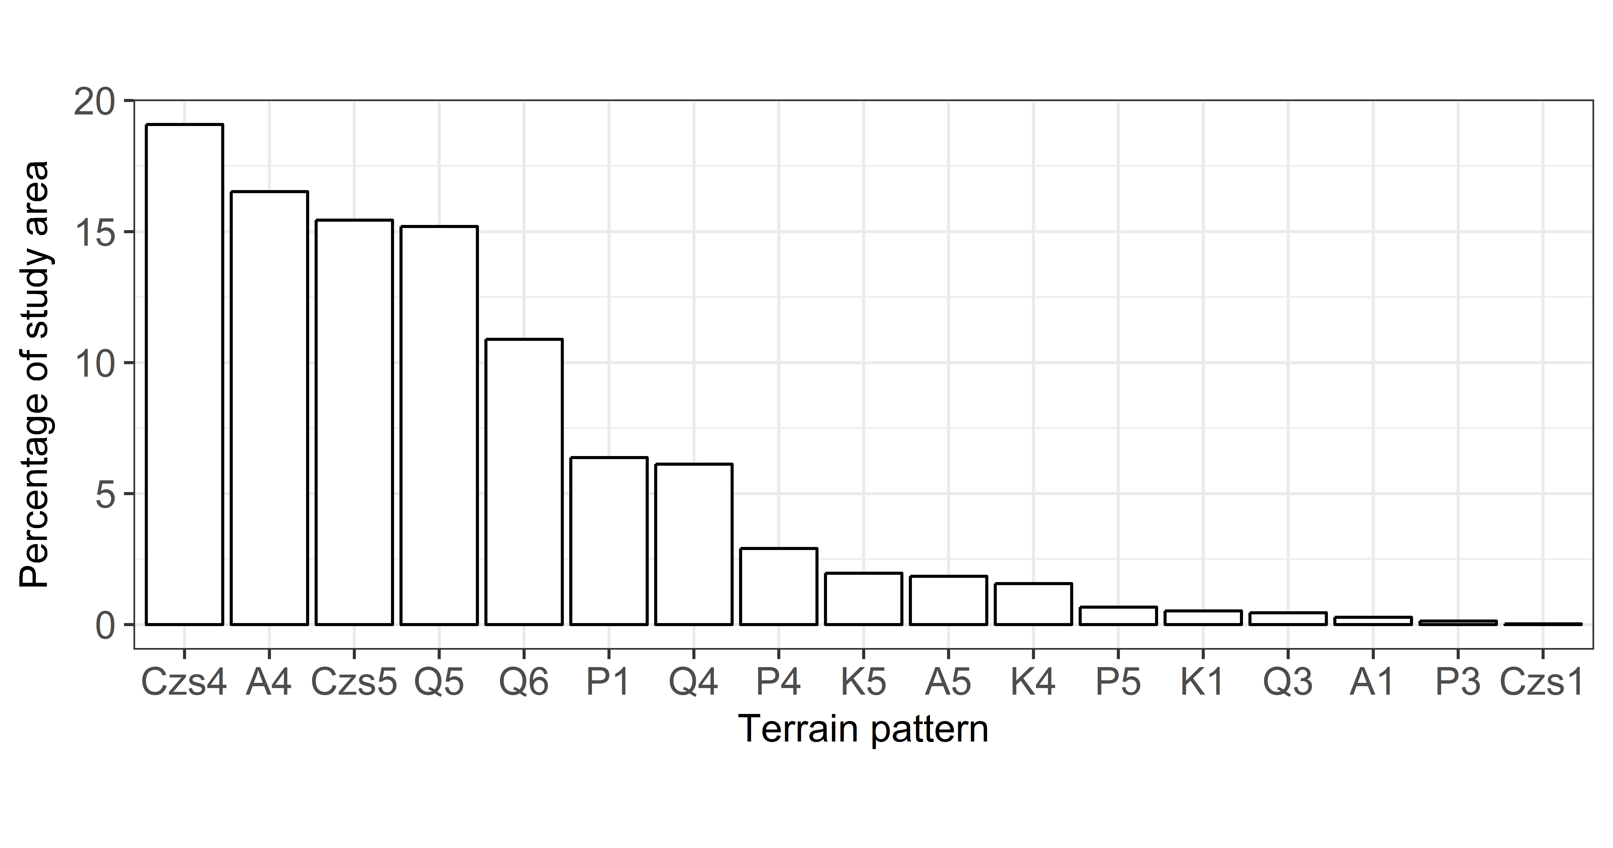

Figure 8 Terrain pattern percentage coverage of the 2007-2008 study area

A wide variety of landforms and geological regimes were recorded, displayed in figure 8 as the percentage coverage of each terrain pattern. In total these areas contained about 10,615 archaeological sites. Most of the study area consists of widely spaced dunes – landform type 4 (46.2%), moderately spaced dunes – landform type 5 (35.1%) and closely spaced dunes – landform type 6 (10.9%), mainly overlying Tertiary stony-plains (Czs4 and Czs5) but some overlying limestone (A) or quartzite surfaces (K and P). Other terrain patterns make up less than 10% of the 353 km2 study area (Figure 8).

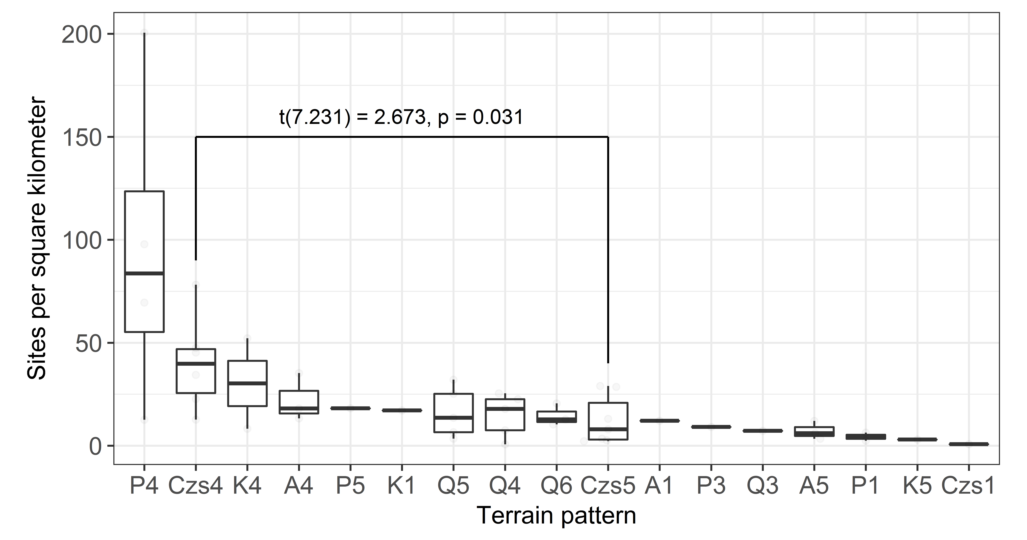

Figure 9 Site density in each terrain pattern. Annotation shows the result of a t-test to compare site densities in the two largest terrain patterns, Czs4 and Czs5

About 44% of all sites were recorded in these two terrain patterns (Czs4: 33.8%, Czs5: 10.7%) with no other terrain pattern having more than 19% of all sites. When considered as homogeneous units, there are marked differences in the frequency of archaeological sites and the density of stone artefacts between these two terrain patterns. As predicted (Table 2), sites are more frequent in fields of widely spaced dunes (Czs4) with 40 sites/km2 compared with more closely spaced dunes (Czs5) which have only 8 sites/km2 (t(7.231) = 2.673, p-value = 0.031) (Figure 9). Also as predicted by the original model the density of surface-visible stone artefacts was substantially higher in areas of widely spaced dunes (Czs4), at 35,789 artefacts/km2, compared with closely spaced dunes Czs5 at 2,702 artefacts/km2.

### Landscape boundary effects

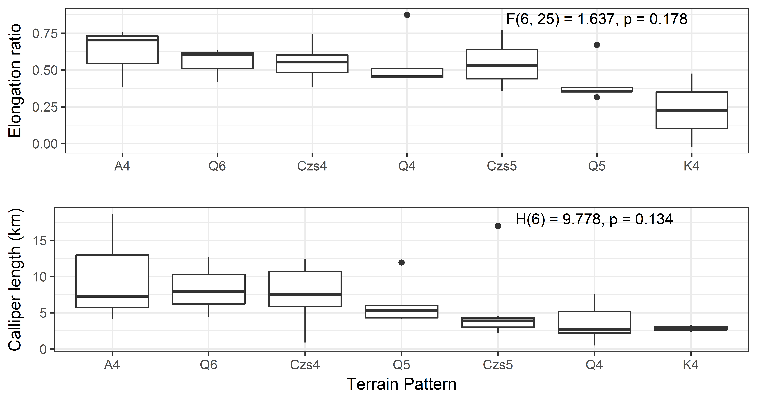

Figure 10 Upper: Distribution of elongation ratios of terrain pattern polygons in the study area. The ANOVA output in the upper right of the plot indicates that there is no significant difference in the elongation ratios of the terrain patterns. Lower: Distribution of calliper lengths (longest distance between two points) of the terrain patterns in the study area. The Krukall-Wallis test in the upper right of the plot indicates that there is no significant difference in the lengths of the terrain patterns.

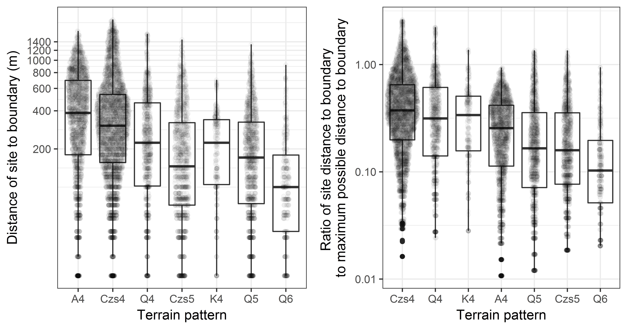

Figure 11 Left: Distributions of distances of archaeological sites to terrain pattern bounaries. Right: Distributions of ratios of observed distance of site to terrain pattern boundary and the maximum possible distance to boundary for each terrain pattern. Distance is shown on the vertical axis with a logarithmic scale. Data points show distance values for individual sites.

Figure ?? depicts distances of sites from the boundaries of the terrain pattern that contains those sites. The sample of sites in this figure is limited to terrain pattern areas that are on average more than 1 km across (cf. Figure 5). The general pattern is clear, with distances to the boundary being substantially further in widely spaced dunefields such landform type 4 (e.g. A4, Czs4 and Q4) than in more closely spaced dunefields such as landform types 5 and 6 (e.g. Czs5, Q5and Q5). This means that sites tend to be nearer to the centers of landform type 4, but nearer to the boundaries of landform type 5. Visual inspection of Figure 5 shows that this relationship is not dependent simply on the size or shape of the terrain patterns.

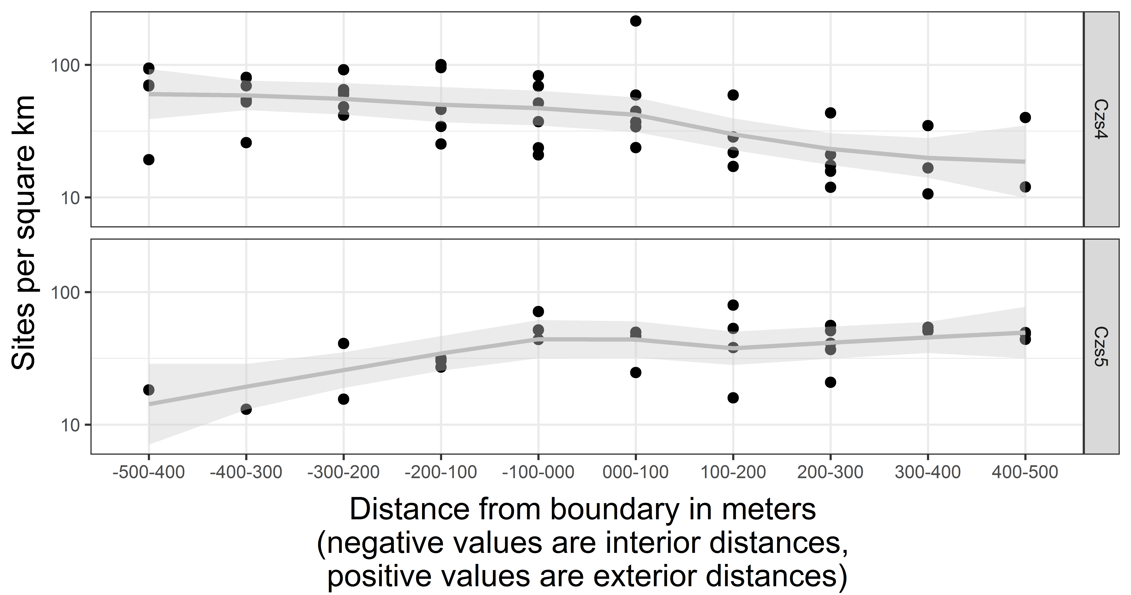

Figure 12 Site density by distance to the boundary of the terrain pattern for Czs4 and Czs5. Data points show site density values for each buffer zone.

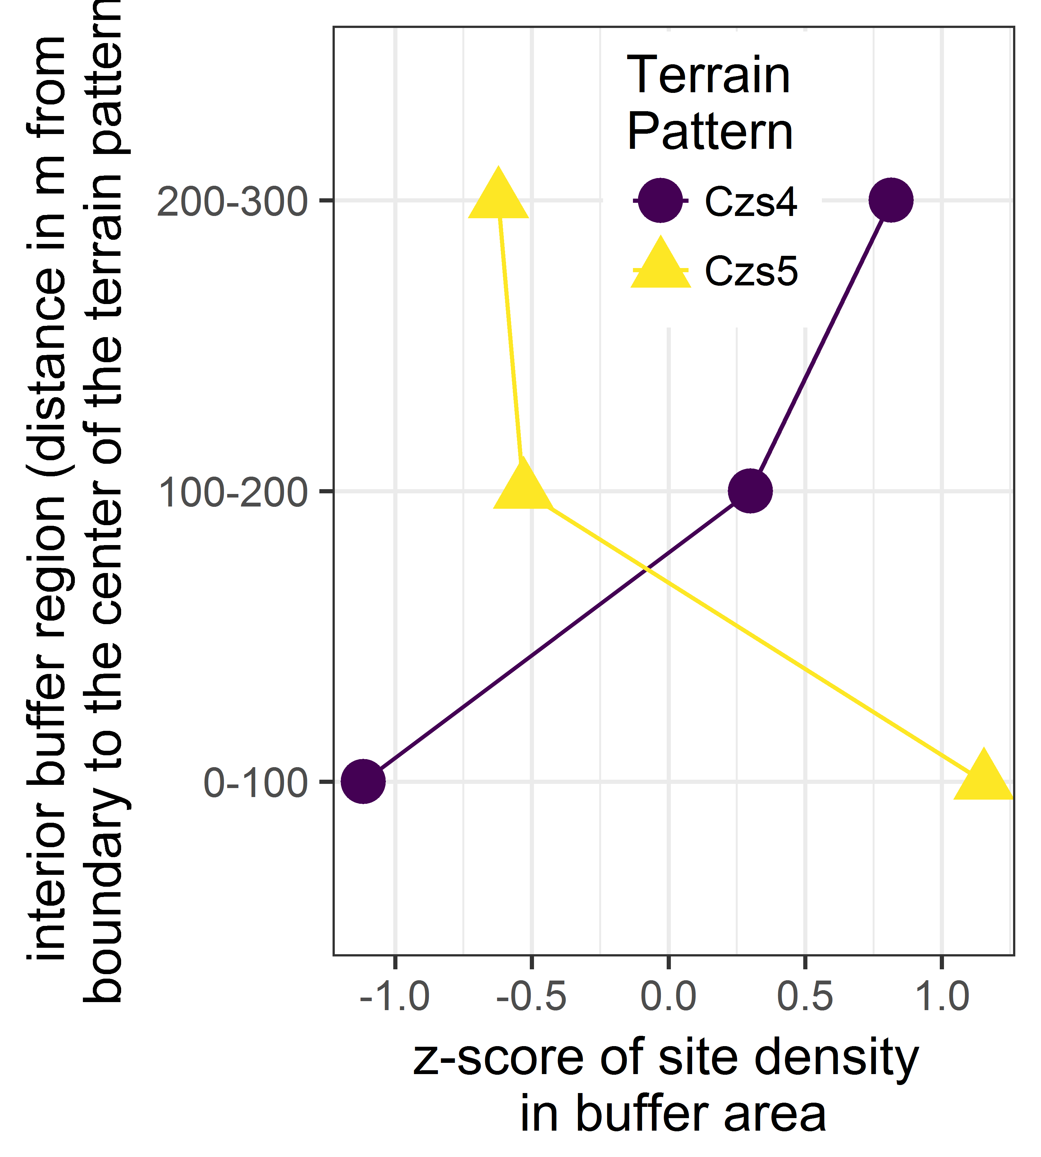

Figure 13 Z-scores for site density in interior buffer zones for Czs4 and Czs5

Figure 12 shows that in Czs4 landscapes the density of sites increases toward the center of the landform while in Czs5 landforms site density decreases towards the center of the landform. The results of a two-way ANOVA show that the interaction of terrain patterns and the distances from the boundary have a significant effect on the density of archaeological sites at increasing distance from the boundary of the terrain pattern units (F(1, 7) = 3.768, p = 0.003, excluding the 0-100 m zone).

When we use z-scores to standardize for differences in site density between two terrain patterns, we see that the pattern is even more stark. Figure 13 shows that in Czs4 landscapes the density of sites increases toward the center of the landform while in Czs5 landforms site density decreases towards the center of the landform. This also minimizes the effects of differences in the sizes of landscape units by limiting analysis to an area 300 m from the boundary of the terrain pattern, thereby excluding sites in the middle of very large area terrain patterns. These analyses give support to the prediction that resource-rich landscapes such as Csz4 have sites located away from their margin and far inside the terrain pattern areas while landscapes with lower resource levels such as Csz5 commonly have sites closer to their margins and fewer sites further in their interiors.

## Discussion

In our measurements of site location and site densities, we observed that subtle differences in physical features of the landscape had significant effects on where people were active on the study area during the Holocene. Tests of our model's predictions were facilitated by two characteristics that are distinctive to this project. One is that the extensive survey area, the intensive level of survey and the resulting large sample size of archaeological sites, meant that observation of human choices and behaviour could be obtained at a very high spatial resolution. The second is that objective and robust environmental classifications, creating well-defined terrain patterns, made it possible to quantify landscape diversity in the study area at a high spatial resolution and reduce false associations that could result from less accurate environmental mapping.

We found both more archaeological sites per square kilometer, and more artefacts per square kilometer, in landforms with more widely spaced dunes. This is consistent with our model, and our field observations that more and denser sites tended to occur occur near exposures of good-quality flakeable stone that are often found in interdunal swales (Hughes et al. 2014a). In areas where the sand dunes are more closely spaced, such as landform types 5 and 6, the dune flanks flow into each other, leaving few or no swales between the dunes where surface outcrops of flakable stone might be exposed. This differential availability of flakable stone may be an important factor that influenced ancient peoples' use of this landscape.

Our analysis of boundary effects shows people were sensitive to subtle gradients of change in the physical environment. We found that sites were generally located further from the terrain pattern boundary in landform type 4, compared to landform types 5 and 6. This indicates that people preferred to be located close to the center of areas with widely-spared dunes, but only on the edges of the areas with closely spaced dunes. Looking at this in more detail, we found that for Czs4 and Czs5 there is a clear contrast in the density of sites when we compare areas close to the middle of the terrain patterns with areas further away from the boundary of the terrain patterns.

This analysis suggests that prehistoric people in the Roxby dunefield area were sensitive to fine-grained differences in the economic potential of dissimilar terrain patterns. The novel element of the data presented here is that the distribution of human activities varies substantially and predictably within as well as between terrain patterns. It is also noteworthy that relatively subtle geographic differences between landscapes – the different spacing of sand dunes between Czs4 and Czs5 – has a marked effect on the distribution of archaeological sites. We speculate that this is due to the relationship between dune spacing and the availability of flakable stone, as well as other resources. The causes of variation in dune spacing are poorly understood. Previous work has associated sand transport rates and directions, wind regime characteristics, grain size patterns, topography, and substrates with dune spacing, however there are no simple relationships (Lancaster 1988; Wasson and Hyde 1983; Wasson et al. 1988).

## Conclusion

The substantive archaeological contribution of this study has been to show that when choosing habitations, prehistoric people in the Roxby dunefield were sensitive to relatively small variations in the landscape, such as the spacing of dunes. The implication of this finding is that even in relatively homogeneous landscapes, such as the desert investigated here, there are gradient-like patterns in the distribution of archaeological sites the reveal how people adapted to the landscape (cf. Attwell and Fletcher 1987). Although Australian deserts are home to some unique flora and fauna, the general patterns of gradients of human behaviour observed here are not contingent on any specific taxa. We expect that beyond the sand dunes of Australia, gradients might also be observed in the archaeological record of the U.S. Great Basin, the coastal and high altitude deserts of South America, and the core deserts of Africa. Gradients are likely to be an indicator of a generic adaptation to landscape variation that can be found in many ecosystems. These gradients allow for more sophisticated interpretations of prehistoric behaviour beyond the obvious attraction of prominent landscape features (Wilson 2007; Kowalewski 2008: 233). Given a large enough dataset, such as the one presented here, these patterns can be quickly quantified using a geographical information system and explained with relatively simple behavioural ecological models. We hope that this data-intensive approach to using gradients of changes in archaeological site attributes across the landscape might suggest a new direction for investigating past human behaviour at ecological interfaces, avoiding the problematic assumptions of previous work on edge effects.

The methodological contribution of this study has been to demonstrate the advantage of using a mobile GIS for field data collection in a context where data collection is intensive, data volume is high, a highly structured data collection form is used, and the start-up, purchasing, and training costs could be amortized over multiple years of data collection. Our gain of 63% is within the range documented by other studies using mobile data collection technologies. For example, Poehler and Ellis (2012) report a 371% increase in efficiency using iPads at Pompeii, and Austin (2014) reports a 21-32% increase when using Open Data Kit (Hartung et al. 2010) to record skeletal remains. This wide variation in efficiency gains suggests that the magnitude of the gain is highly dependent on the context in which the mobile technologies are employed.

## Acknowledgments

The fieldwork component of this study was undertaken as part of a broader investigation in accordance with the Olympic Dam Agreement between BHP Billiton and the Aboriginal native title claimant groups under a contract with BHP Billiton that included research support. Other financial support for Ben Marwick came from a Luce/ACLS Post-doctoral fellowship (B9471 01 180401 7301), a grant from the Herbert H. Gowen International Studies Endowment (UW Office of Global Affairs), and an Australian Research Council Future Fellowship (FT140100101).

##### 

## References

Attwell, M. R. and M. Fletcher (1987). "An analytical technique for investigating spatial relationships." Journal of Archaeological Science 14(1): 1-11.

Austin, A. 2014 Mobilizing Archaeologists: Increasing the Quantity and Quality of Data Collected in the Field with Mobile Technology. Advances in Archaeological Practice 2(1):13-23.

Badman, F. J. (1999). "The Lake Eyre South Study: Vegetation." Lake Eyre South Monograph Series 2: 176-200.

Banning, E. B. and P. Hitchings (2015). "Digital Archaeological Survey: Using iPads In Archaeological Survey In Wadi Quseiba, Northern Jordan." The SAA Archaeological Record 15(4): 31-36.

Barton, H. (2003). "The Thin Film of Human Action: interpretations of Arid Zone Archaeology." Australian Archaeology 57: 32-41.

Bevan, A. and J. Conolly (2004). "GIS, Archaeological Survey, and Landscape Archaeology on the Island of Kythera, Greece." Journal of Field Archaeology 29(1-2): 123-138.

Bird, M. I., O’Grady, D., & Ulm, S. (2016). "Humans, water, and the colonization of Australia." Proceedings of the National Academy of Sciences, 113(41), 11477-11482.

Cascalheira, J., C. Gonçalves and N. Bicho (2014). "Smartphones and the use of customized Apps in archaeological projects." The SAA Archaeological Record 14(5): 20-25.

Daniel, I. R., Jr. (2001). "Stone Raw Material Availability and Early Archaic Settlement in the Southeastern United States." American Antiquity 66(2): 237-265.

Davies, B., S. J. Holdaway and P. C. Fanning (2015). "Modelling the palimpsest: An exploratory agent-based model of surface archaeological deposit formation in a fluvial arid Australian landscape." The Holocene: 0959683615609754.

de la Vega, S. G.-D. and S. O. Agulla (2010). Using mobile GIS. for Field Digital Data Acquisition (FDA) in archaeological field survey. Geoinformation Technologies for Geo-Cultural Landscapes: European Perspectives. A. Vassilopoulos, N. Evelpidou, O. Bender and A. Krek: 35-46.

Dunnell, R. C. and W. S. Dancey (1983). "The Siteless Survey: A Regional Scale Data Collection Strategy." Advances in Archaeological Method and Theory 6: 267-287.

Epp, H. T. (1985). "Ecological Edges and Archaeological Site Location in Saskatchewan, Canada." North American Archaeologist 5(4): 323-336.

Fanning, P. C., S. J. Holdaway and E. J. Rhodes (2008). "A new geoarchaeology of Aboriginal artefact deposits in western NSW, Australia: establishing spatial and temporal geomorphic controls on the surface archaeological record." Geomorphology 101(3): 524-532.

Fee, S. B., D. K. Pettegrew and W. R. Caraher (2013). "Taking Mobile Computing to the Field." Near Eastern Archaeology (NEA) 76(1): 50-55.

Fei, G. (2011). "Data Acquisition of Field Archaeological Supported by PDA+ GPS and ArcPad." Journal of Hefei University (Natural Sciences) 2: 011.

Foley, R. (1981). Off-site archaeology: an alternative approach for the short-sited. Pattern of the past: studies in honour of David Clarke. I. Hodder, G. Isaac and N. Hammond. Cambridge, Cambridge University Press: 157-183.

Given, O. and S. Hyla (2006). "Forging Partnerships in Laos." Expedition 48(1): 38-39.

Glassow, M. A. and M. Leone (1972 ). Changes in the Adaptations of Southwestern Basketmakers: a Systems Perspective. Contemporary Archaeology. M. Leone, Southern Illinois University Press: 289-302.

Gould, R. A., & Saggers, S. (1985). Lithic procurement in Central Australia: a closer look at Binford's idea of embeddedness in archaeology. American Antiquity, 117-136. Chicago

Gumerman, G. J. and R. R. Johnson (1971). "Prehistoric human population distribution in a biological transition zone." The distribution of prehistoric population aggregates," edited by George J. Gumerman: 83-102.

Hardesty, D. L. (1980). "The Use of General Ecological Principles in Archaeology." Advances in Archaeological Method and Theory 3: 157-187.

Harris, D. R., P. J. Ucko and G. Dimbleby (1969). "Agricultural systems, ecosystems and the origins of agriculture." The domestication and exploitation of plants and animals.: 3-15.

Hartung, C., A. Lerer, Y. Anokwa, C. Tseng, W. Brunette and G. Borriello 2010 Open data kit: Tools to build information services for developing regions. Proceedings of the 4th ACM/IEEE International Conference on Information and Communication Technologies and Development: ACM.

Hiscock, P. (1989). Artefact recording in the field. Sites and Bytes. Recording Aboriginal places in Australia. J. Flood, I. Johnson and S. Sullivan. Canberra, Australian Government Publishing Service: .20-38.

Hiscock, P. and P. J. Hughes (1983). "One method of recording scatters of stone artefacts during site surveys." Australian Archaeology 17: 87-98.

Holdaway, S. (1998). New approaches to open site spatial archaeology in Sturt National Park, New South Wales, Australia. Archaeology in Oceania.

Holdaway, S. J., M. J. Douglass and P. C. Fanning (2013). "A new ecological framework for understanding human environment interactions in arid Australia." Archaeology in environment and technology intersections and transformations: 51-68.

Hughes, P. and P. Hiscock (2005). The archaeology of the Lake Eyre South area. The archaeology of the Lake Eyre South Region. W. J. H. Slaytor. Adelaide, Royal Geographical Society of South Australia. 6: 1-20.

Hughes, P. J. and P. Hiscock (1982). Annex 5. Olympic Dam Draft Environmental Impact Statement. Unpublished Report to Roxby Management Services Pty Ltd through Kinhill Stearns Roger Pty Ltd, Adelaide.

Hughes, P., P. Hiscock, M. Sullivan and B. Marwick (2011). "An outline of archaeological investigations for the Olympic Dam Expansion in arid northeast South Australia." Journal of the Anthropological Society of South Australia 34: 21-37

Hughes, P., M. Sullivan, P. Hiscock and A. Neyland (2014a) The Need to Have Understood Your Local Geology: Nature and Sources of Materials Used to Manufacture Stone Artefacts at Olympic Dam, South Australia. Journal of the Anthropological Society of South Australia 34: 108-135.

Hughes, P., M. Sullivan, F. Williams, N. Spooner and D. Questiaux (2014b). Sand dune formation over the last 140 ka in the Roxby dunefield, arid northern South Australia. Quaternary Australasia 31(1):11.

Jones, G. T., C. Beck, E. E. Jones and R. E. Hughes (2003). "Lithic source use and paleoarchaic foraging territories in the Great Basin." American Antiquity 68(1): 5-38.

Kimes, T., C. Haselgrove and I. Hodder (1982). "A method for the identification of the location of regional cultural boundaries." Journal of Anthropological Archaeology 1(2): 113-131.

King, F. B. and R. W. Graham (1981). "Effects of Ecological and Paleoecological Patterns on Subsistence and Paleoenvironmental Reconstructions." American Antiquity 46(1): 128-142.

Kowalewski, S. A. (2008). "Regional settlement pattern studies." Journal of Archaeological Research 16(3): 225-285.

Kuna, M. (2000). Surface artefact studies in the Czech Republic. The Future of Surface Artefact Survey in Europe, Sheffield Academic Press, Sheffield, UK. J. Bintliff, M. Kuna and N. Venclova. Sheffield, Sheffield Archaeological Monographs: 29-44.

Lancaster, N. (1988). Controls of eolian dune size and spacing. Geology, 16(11), 972-975.

McPherron, S. and H. Dibble (2003). "Using computers In adverse field conditions: Tales from the Egyptian desert." The SAA Archaeological Record 3(5): 28-32.

Marwick, B. (2016). Computational reproducibility in archaeological research: Basic principles and a case study of their implementation. Journal of Archaeological Method and Theory, 1-27, doi: 10.1007/s10816-015-9272-9 Napton, L. K. and E. A. Greathouse (1996). Archaeological investigations in the Simpson Desert, Northern Territory. Archaeology of Northern Australia. P. Veth and P. Hiscock. Brisbane, University of Queensland. TEMPUS Volume 4: 106-136.

Newhard, J. M. L., N. S. Levine, A. D. Phebus, S. Craft and J. D. Littlefield (2013). "A geoinformatic approach to the collection of archaeological survey data." Cartography and Geographic Information Science 40(1): 3-17.

Poehler, E.E. and S.J.R. Ellis 2012 The 2011 Season of the Pompeii Quadriporticus Project: The Southern and Northern Sides. Fasti Online Documents and Research 249:1-12.

Rhoades, R. E. (1978). "Archaeological Use and Abuse of Ecological Concepts and Studies: The Ecotone Example." American Antiquity 43(4): 608-614.

Scianna, A. and B. Villa (2011). "GIS applications in archaeology." Archeologia e Calcolatori 22: 337-363.

Smith, M., A. Williams, C. Turney and M. Cupper (2008). "Human—environment interactions in Australian drylands: exploratory time-series analysis of archaeological records." The Holocene 18(3): 389-401.

Smith, M. A. (2006). "Characterizing late Pleistocene and Holocene stone artefact assemblages from Puritjarra rock shelter: a long sequence from the Australian desert." Records of the Australian Museum 58: 371-410.

Struever, S. (1968). Woodland subsistence-settlement systems in the lower Illinois Valley. New perspectives in archaeology. S. R. Binford and L. R. Binford. Chicago, Aldine: 285-312.

Sullivan, M., T. L. Field, P. Hughes, B. Marwick, P. Przystupa and J. K. Feathers (2012). "OSL ages that inform late phases of dune formation and human occupation near Olympic Dam in Northeastern South Australia." Quaternary Australasia 29(1): 4-11.

Sullivan, M., P. Hiscock, and P. Hughes (2014a) Three Scales: GIS, GPS and Digital Site and Data Recording Technology in Archaeological Salvage at Olympic Dam in Arid South Australia. Journal of the Anthropological Society of South Australia 38: 85-107.

Sullivan, M., P. Hughes, A. Mosig Way and N. Spooner (2014b). Prehistoric mining at Olympic Dam in arid South Australia. Archaeology in Oceania 49(1):43-55.

Thomas, D. H. (1975). Nonsite sampling in archaeology: up the creek without a site. Sampling in archaeology. J. W. Mueller. Tucson, AZ, University of Arizona Press: 61-81.

Traviglia, A. (2011). Integrated Archaeological Investigations for the Study of the Greater Aquileia Area. The New Technologies for Aquileia, Aquileia, Italy.

Tripcevich, N. (2004a). "Flexibility by Design: How Mobile GIS Meets the Needs of Archaeological Survey." Cartography and Geographic Information Science 31(3): 137-151.

Tripcevich, N. (2004b). "Mobile GIS in archaeological survey." The SAA Archaeological Record(May).

Tripcevich, N. and S. A. Wernke (2010). "On-site recording of excavation data using mobile GIS." Journal of Field Archaeology 35(4): 380-397.

Veth, P. (1993). "Islands in the Interior: A Model for the Colonisation of Australia's Arid Zone." Archaeology in Oceania 24: 81-92.

Veth, P., M. Smith and M. Haley (2001). "Kaalpi: The archaeology of an outlying range in the dunefields of the Western Desert." Australian Archaeology(52): 9-17.

Veth, P., M. Smith and P. Hiscock (2008). Desert peoples: archaeological perspectives, John Wiley & Sons.

Wagtendonk, A. J. and R. A. M. De Jeu (2007). "Sensible field computing: Evaluating the use of mobile GIS methods in scientific fieldwork." Photogrammetric Engineering and Remote Sensing 73(6): 651.

Wasson, R. J., Fitchett, K., Mackey, B., & Hyde, R. (1988). Large‐scale patterns of dune type, spacing and orientation in the Australian continental dunefield. The Australian Geographer, 19(1), 89-104.

Wasson, R. J., & Hyde, R. (1983). Factors determining desert dune type. Nature, 304(5924), 337-339.

Williams, A. N., S. Ulm, A. R. Cook, M. C. Langley and M. Collard (2013). "Human refugia in Australia during the Last Glacial Maximum and terminal Pleistocene: A geospatial analysis of the 25–12 ka Australian archaeological record." Journal of Archaeological Science 40(12): 4612-4625.

Wilson, L. (2007). "Understanding prehistoric lithic raw material selection: application of a gravity model." Journal of Archaeological Method and Theory 14(4): 388-411.

##### .

### Colophon

This report was generated on 2017-06-06 14:36:49 using the following computational environment and dependencies:

Table 4 R session information

|  |  |
| --- | --- |
| Setting | Value |
| version | R version 3.4.0 Patched (2017-05-10 r72670) |
| system | x86_64, mingw32 |
| ui | RTerm |
| language | (EN) |
| collate | English_Australia.1252 |
| tz | Australia/Sydney |
| date | 2017-06-06 |

Table 5 Packages that this report depends on

|  |  |  |  |  |
| --- | --- | --- | --- | --- |
| package | * | version | date | source |
| ape |  | 4.1 | 2017-02-14 | CRAN (R 3.4.0) |
| assertthat |  | 0.1 | 2013-12-06 | CRAN (R 3.4.0) |
| backports |  | 1.1.0 | 2017-05-22 | CRAN (R 3.4.0) |
| base | * | 3.4.0 | 2017-05-14 | local |
| bookdown |  | 0.4 | 2017-05-20 | CRAN (R 3.4.0) |
| coda |  | 0.19-1 | 2016-12-08 | CRAN (R 3.4.0) |
| colorspace |  | 1.3-2 | 2016-12-14 | CRAN (R 3.4.0) |
| compiler |  | 3.4.0 | 2017-05-14 | local |
| curl |  | 2.6 | 2017-04-27 | CRAN (R 3.4.0) |
| data.table | * | 1.10.4 | 2017-02-01 | CRAN (R 3.4.0) |
| datasets | * | 3.4.0 | 2017-05-14 | local |
| DBI |  | 0.5-1 | 2016-09-10 | CRAN (R 3.4.0) |
| deldir |  | 0.1-12 | 2016-03-06 | CRAN (R 3.4.0) |
| deSolve |  | 1.14 | 2016-09-05 | CRAN (R 3.4.0) |
| devtools |  | 1.13.1 | 2017-05-13 | CRAN (R 3.4.0) |
| digest |  | 0.6.12 | 2017-01-27 | CRAN (R 3.4.0) |
| dplyr | * | 0.5.0 | 2016-06-24 | CRAN (R 3.4.0) |
| evaluate |  | 0.10 | 2016-10-11 | CRAN (R 3.4.0) |
| foreign | * | 0.8-67 | 2016-09-13 | CRAN (R 3.4.0) |
| geiger |  | 2.0.6 | 2015-09-07 | CRAN (R 3.4.0) |
| geojsonlint |  | 0.2.0 | 2016-11-03 | CRAN (R 3.4.0) |
| geometry |  | 0.3-6 | 2015-09-09 | CRAN (R 3.4.0) |
| geomorph |  | 3.0.3 | 2016-09-09 | CRAN (R 3.4.0) |
| ggforce | * | 0.1.1 | 2017-05-24 | Github ([thomasp85/ggforce@dea1d15](mailto:thomasp85/ggforce@dea1d15)) |
| ggplot2 | * | 2.2.1 | 2016-12-30 | CRAN (R 3.4.0) |
| git2r | * | 0.18.0 | 2017-01-01 | CRAN (R 3.4.0) |
| graphics | * | 3.4.0 | 2017-05-14 | local |
| grDevices | * | 3.4.0 | 2017-05-14 | local |
| grid |  | 3.4.0 | 2017-05-14 | local |
| gridExtra | * | 2.2.1 | 2016-02-29 | CRAN (R 3.4.0) |
| gtable |  | 0.2.0 | 2016-02-26 | CRAN (R 3.4.0) |
| htmltools |  | 0.3.6 | 2017-04-28 | CRAN (R 3.4.0) |
| htmlwidgets |  | 0.8 | 2016-11-09 | CRAN (R 3.4.0) |
| httpuv |  | 1.3.3 | 2015-08-04 | CRAN (R 3.4.0) |
| jpeg |  | 0.1-8 | 2014-01-23 | CRAN (R 3.4.0) |
| jsonlite |  | 1.4 | 2017-04-08 | CRAN (R 3.4.0) |
| jsonvalidate |  | 1.0.0 | 2016-06-13 | CRAN (R 3.4.0) |
| knitr | * | 1.16 | 2017-05-18 | CRAN (R 3.4.0) |
| lattice |  | 0.20-35 | 2017-03-25 | CRAN (R 3.4.0) |
| lazyeval |  | 0.2.0.9000 | 2017-05-24 | Github ([hadley/lazyeval@c155c3d](mailto:hadley/lazyeval@c155c3d)) |
| magic |  | 1.5-6 | 2013-11-20 | CRAN (R 3.4.0) |
| magrittr |  | 1.5 | 2014-11-22 | CRAN (R 3.4.0) |
| MASS |  | 7.3-47 | 2017-02-26 | CRAN (R 3.4.0) |
| Matrix |  | 1.2-10 | 2017-05-03 | CRAN (R 3.4.0) |
| memoise |  | 1.1.0 | 2017-04-21 | CRAN (R 3.4.0) |
| methods | * | 3.4.0 | 2017-05-14 | local |
| mime |  | 0.5 | 2016-07-07 | CRAN (R 3.4.0) |
| Momocs | * | 1.1.6 | 2017-04-17 | CRAN (R 3.4.0) |
| munsell |  | 0.4.3 | 2016-02-13 | CRAN (R 3.4.0) |
| mvtnorm |  | 1.0-6 | 2017-03-02 | CRAN (R 3.4.0) |
| nlme |  | 3.1-131 | 2017-02-06 | CRAN (R 3.4.0) |
| parallel |  | 3.4.0 | 2017-05-14 | local |
| plyr | * | 1.8.4 | 2016-06-08 | CRAN (R 3.4.0) |
| R6 |  | 2.2.0 | 2016-10-05 | CRAN (R 3.4.0) |
| Rcpp |  | 0.12.9 | 2017-01-14 | CRAN (R 3.4.0) |
| reshape2 | * | 1.4.2 | 2016-10-22 | CRAN (R 3.4.0) |
| rgeos | * | 0.3-23 | 2017-04-06 | CRAN (R 3.4.0) |
| rgl |  | 0.98.1 | 2017-03-08 | CRAN (R 3.4.0) |
| rmapshaper | * | 0.2.0 | 2017-02-16 | CRAN (R 3.4.0) |
| rmarkdown |  | 1.5 | 2017-04-26 | CRAN (R 3.4.0) |
| rprojroot |  | 1.2 | 2017-01-16 | CRAN (R 3.4.0) |
| scales | * | 0.4.1 | 2016-11-09 | CRAN (R 3.4.0) |
| sf | * | 0.4-3 | 2017-05-15 | CRAN (R 3.4.0) |
| shiny |  | 1.0.3 | 2017-04-26 | CRAN (R 3.4.0) |
| sp | * | 1.2-4 | 2016-12-22 | CRAN (R 3.4.0) |
| stats | * | 3.4.0 | 2017-05-14 | local |
| stringi |  | 1.1.2 | 2016-10-01 | CRAN (R 3.4.0) |
| stringr |  | 1.1.0 | 2016-08-19 | CRAN (R 3.4.0) |
| subplex |  | 1.2-2 | 2016-11-19 | CRAN (R 3.4.0) |
| tibble |  | 1.2 | 2016-08-26 | CRAN (R 3.4.0) |
| tidyr | * | 0.6.1 | 2017-01-10 | CRAN (R 3.4.0) |
| tools |  | 3.4.0 | 2017-05-14 | local |
| tweenr |  | 0.1.5 | 2016-10-10 | CRAN (R 3.4.0) |
| udunits2 |  | 0.13 | 2016-11-17 | CRAN (R 3.4.0) |
| units | * | 0.4-4 | 2017-04-20 | CRAN (R 3.4.0) |
| utils | * | 3.4.0 | 2017-05-14 | local |
| V8 |  | 1.5 | 2017-04-25 | CRAN (R 3.4.0) |
| viridis | * | 0.4.0 | 2017-03-27 | CRAN (R 3.4.0) |
| viridisLite | * | 0.2.0 | 2017-03-24 | CRAN (R 3.4.0) |
| withr |  | 1.0.2 | 2016-06-20 | CRAN (R 3.4.0) |
| xtable |  | 1.8-2 | 2016-02-05 | CRAN (R 3.4.0) |
| yaml |  | 2.1.14 | 2016-11-12 | CRAN (R 3.4.0) |

The current git commit of this file is adec9fc83329530505ae4813584560883cfa8a50, which is on the master branch and was made by Ben Marwick on 2017-06-06 02:36:11. The current commit message is "do ratio of observed site distance to max-min possible dist". The repository is online at <https://github.com/benmarwick/olympicdamboundaries>